**Chrome – with Disable cache ticked in Admin Tools**

On CIG LAN at Numero Stockport

Navigated to [https://optimus.qa.callcreditdisputes.com/numerointeractive/](https://optimus.qa.callcreditdisputes.com/numerointeractive/default.aspx#/)

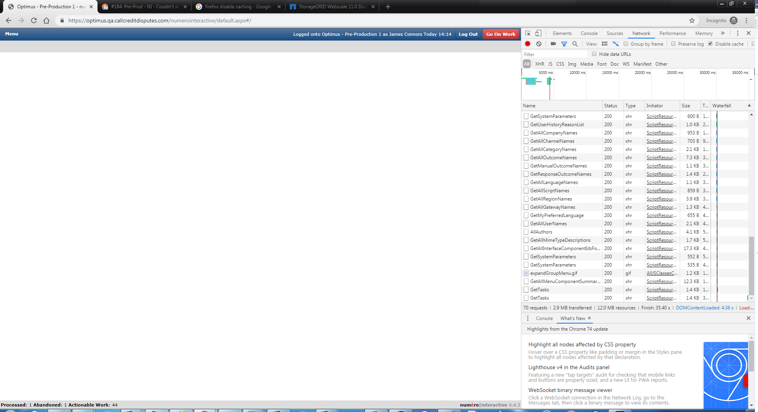

Opened dispute fine;

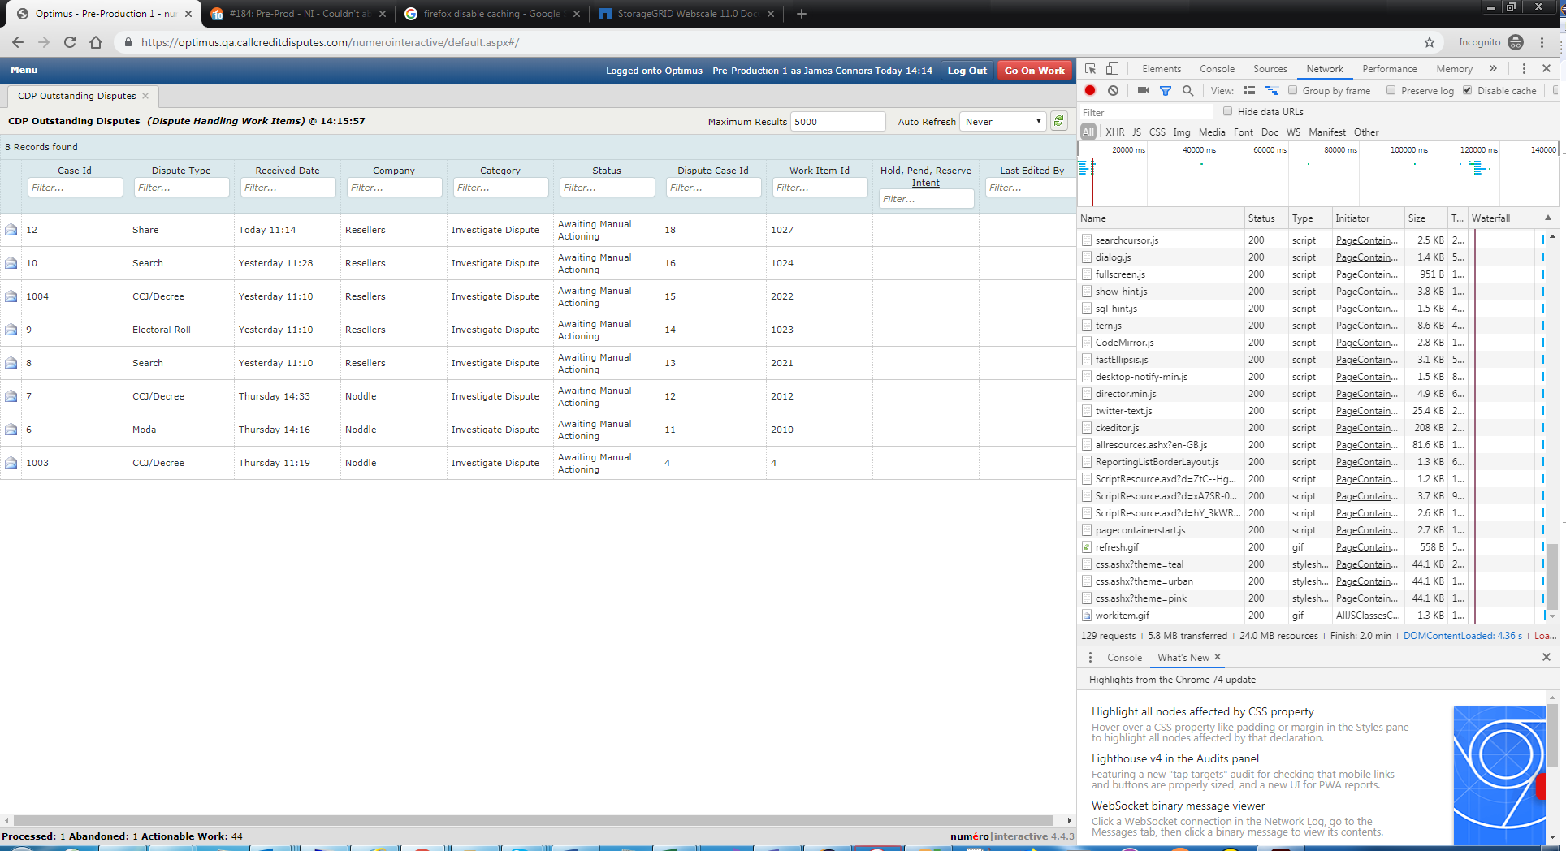

Refreshed browser and able to open dispute fine;

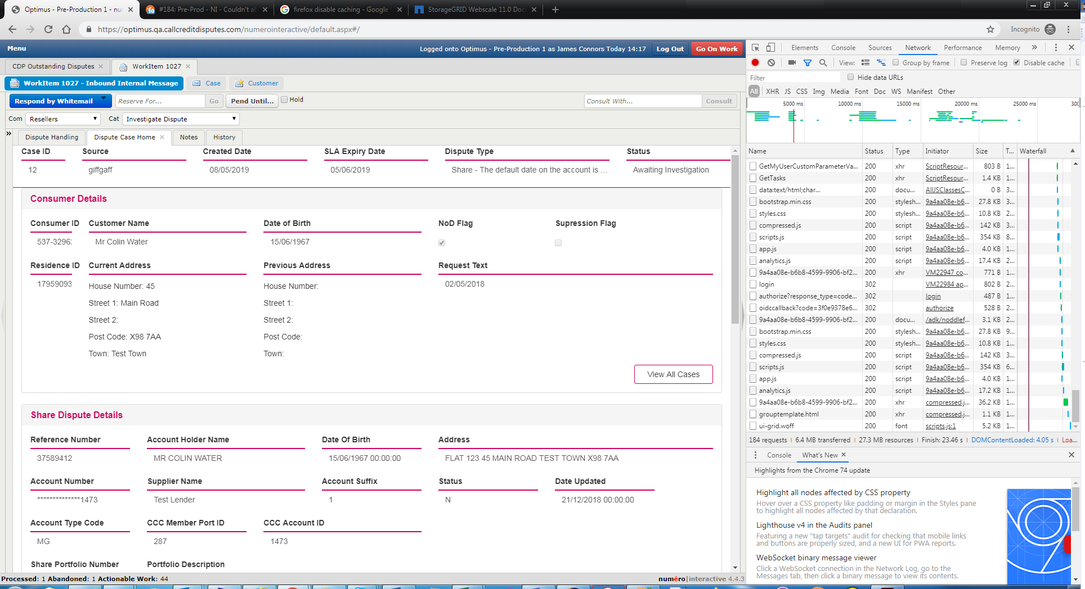

Switched from CIG lan to Cisco AnyConnect-Primary VPN

In the same session;

Closed the dispute;

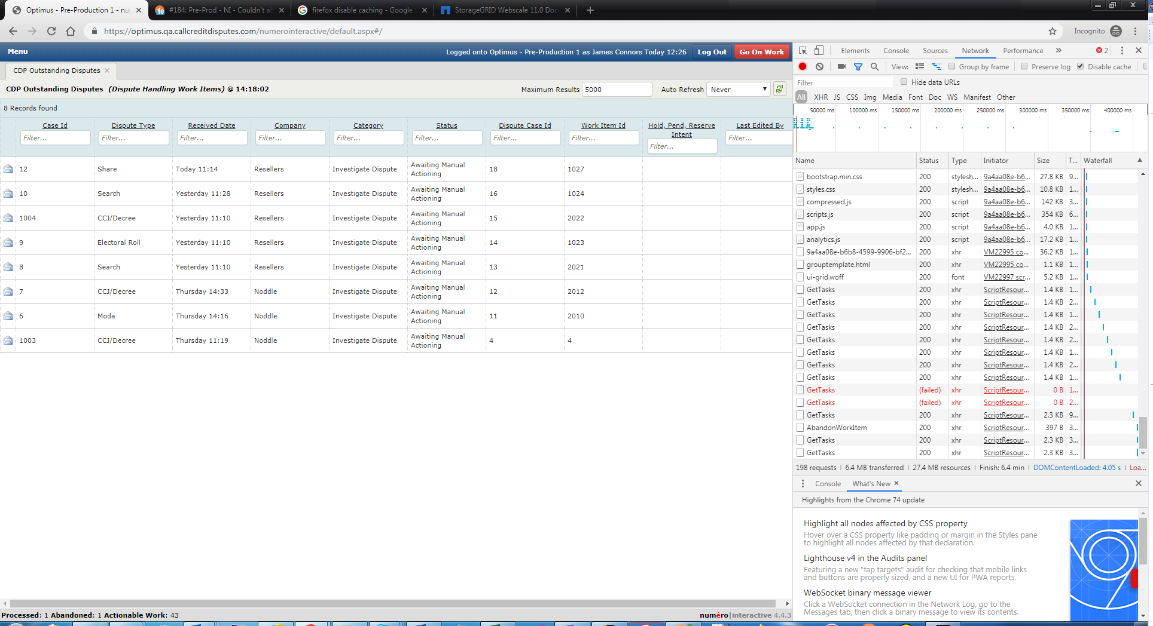

Opened different dispute without issue;

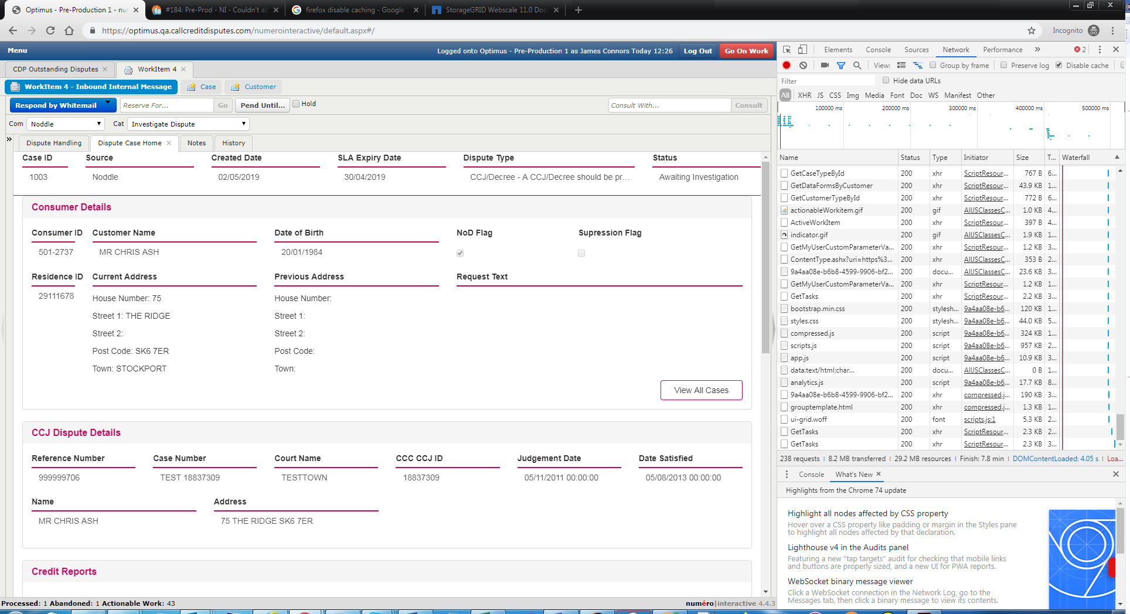

Refreshed browser;

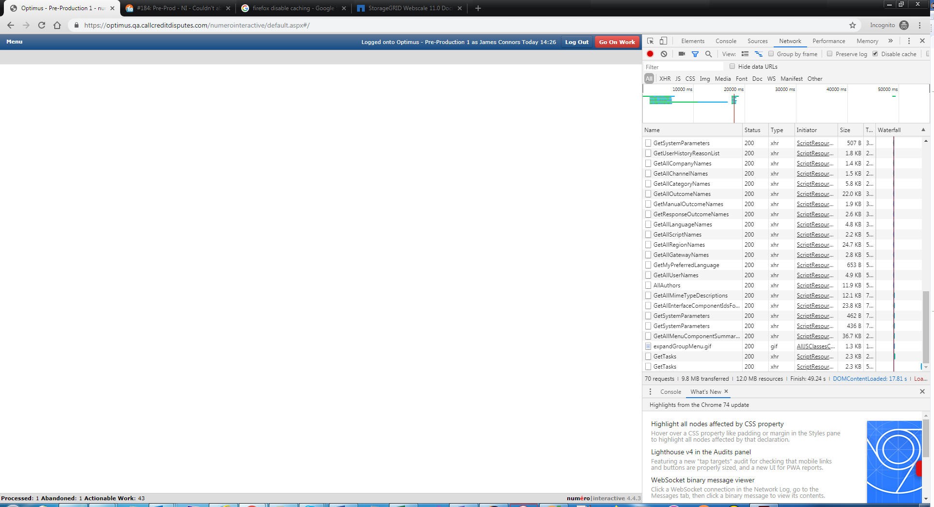

Was able to open dispute without issue;

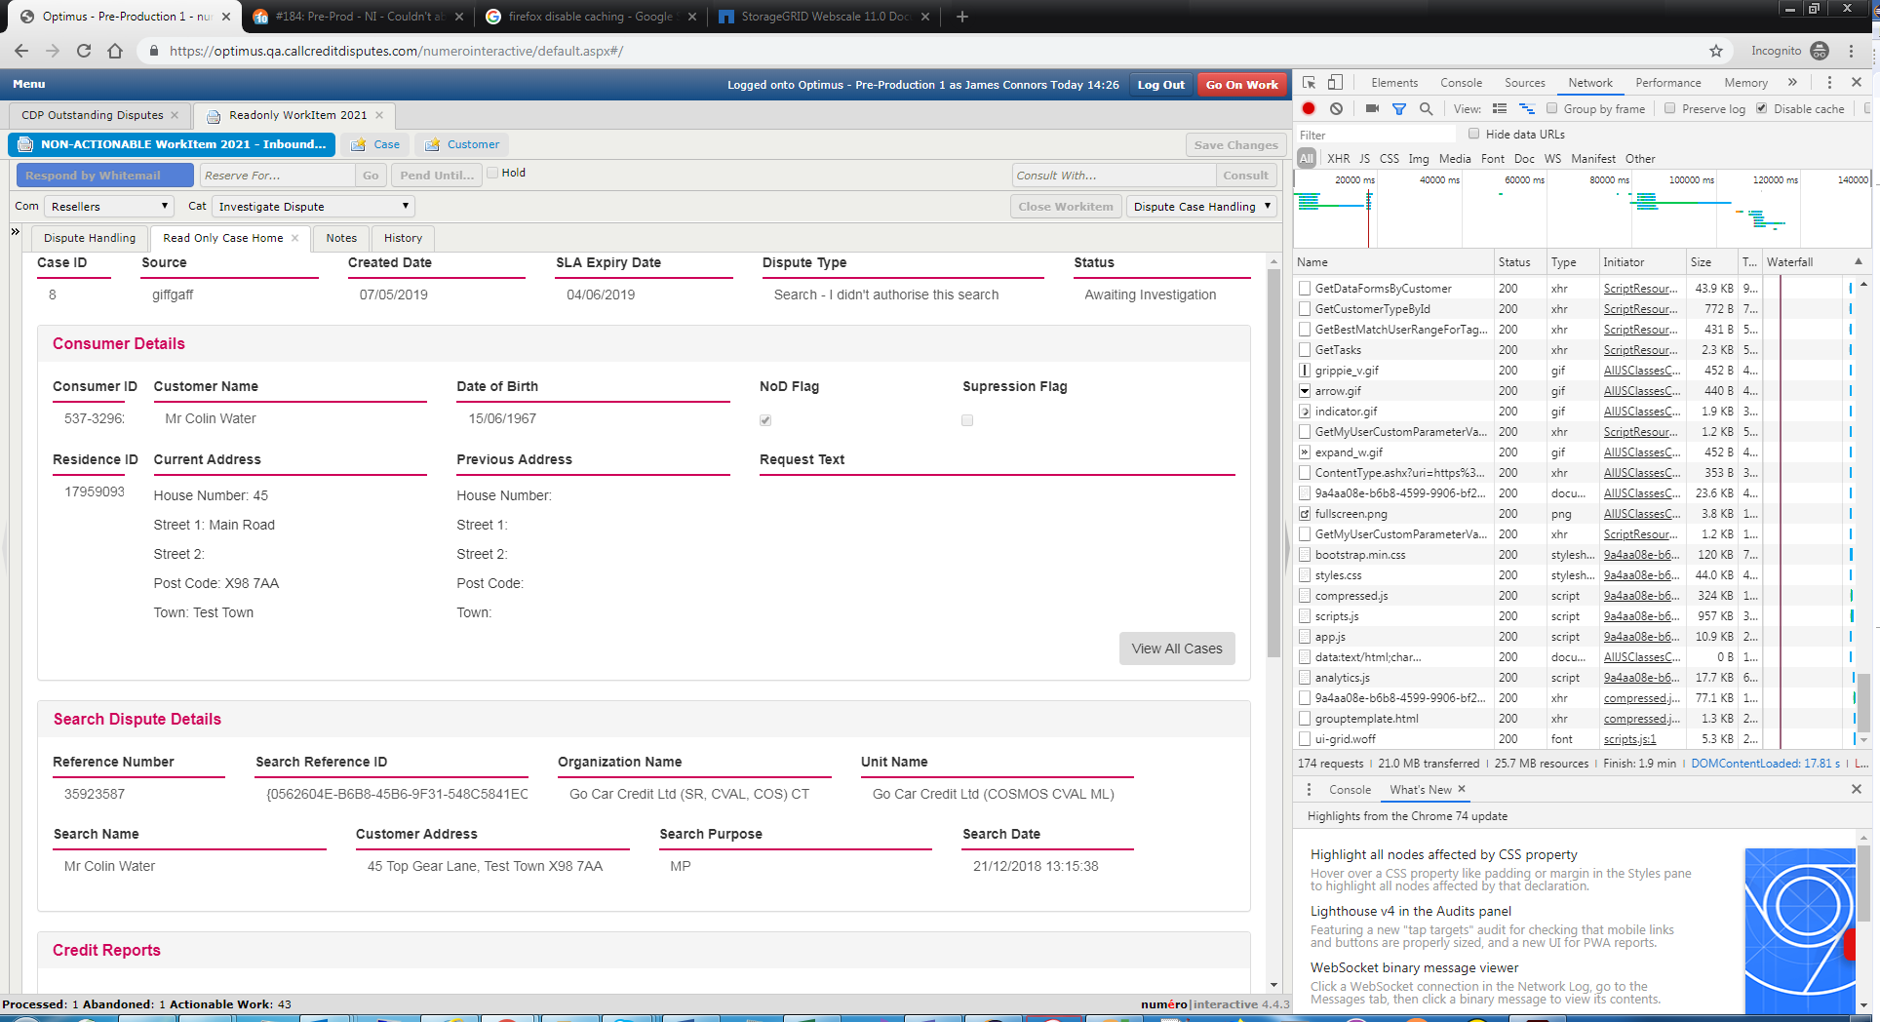

Logged out

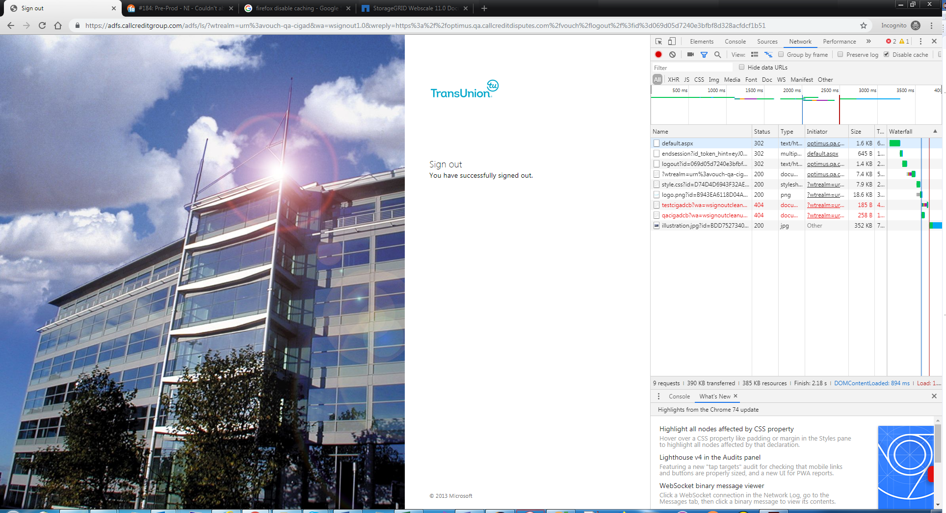

Navigated to <https://optimus.qa.callcreditdisputes.com/numerointeractive>

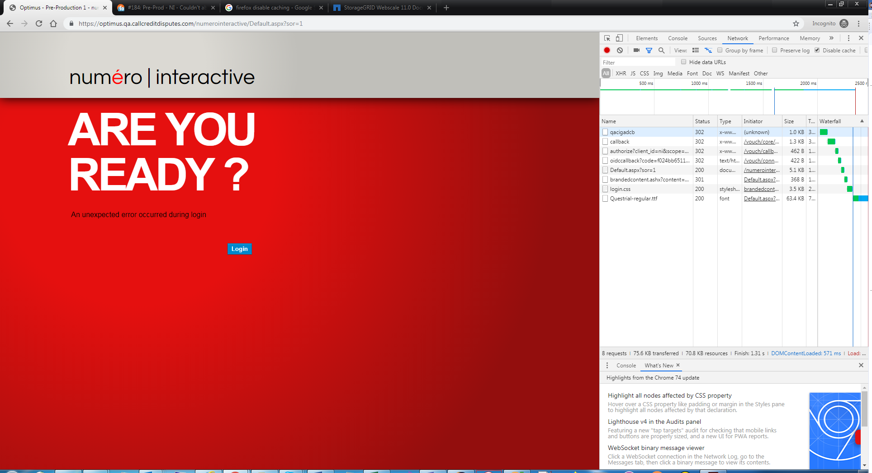

Clicked Login

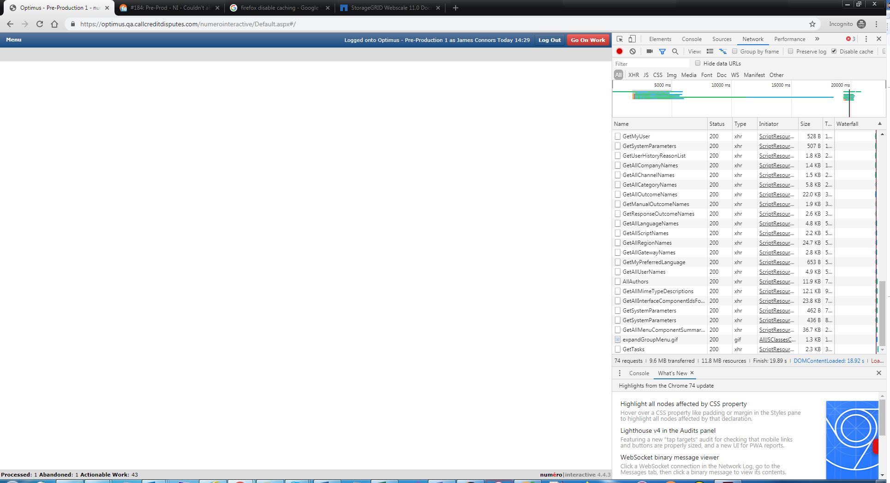

Opened dispute;

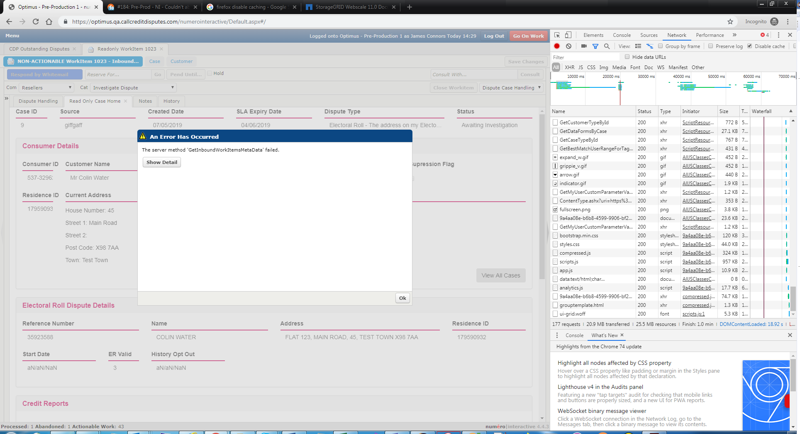

Clicked OK;

Closed dispute and reopened;

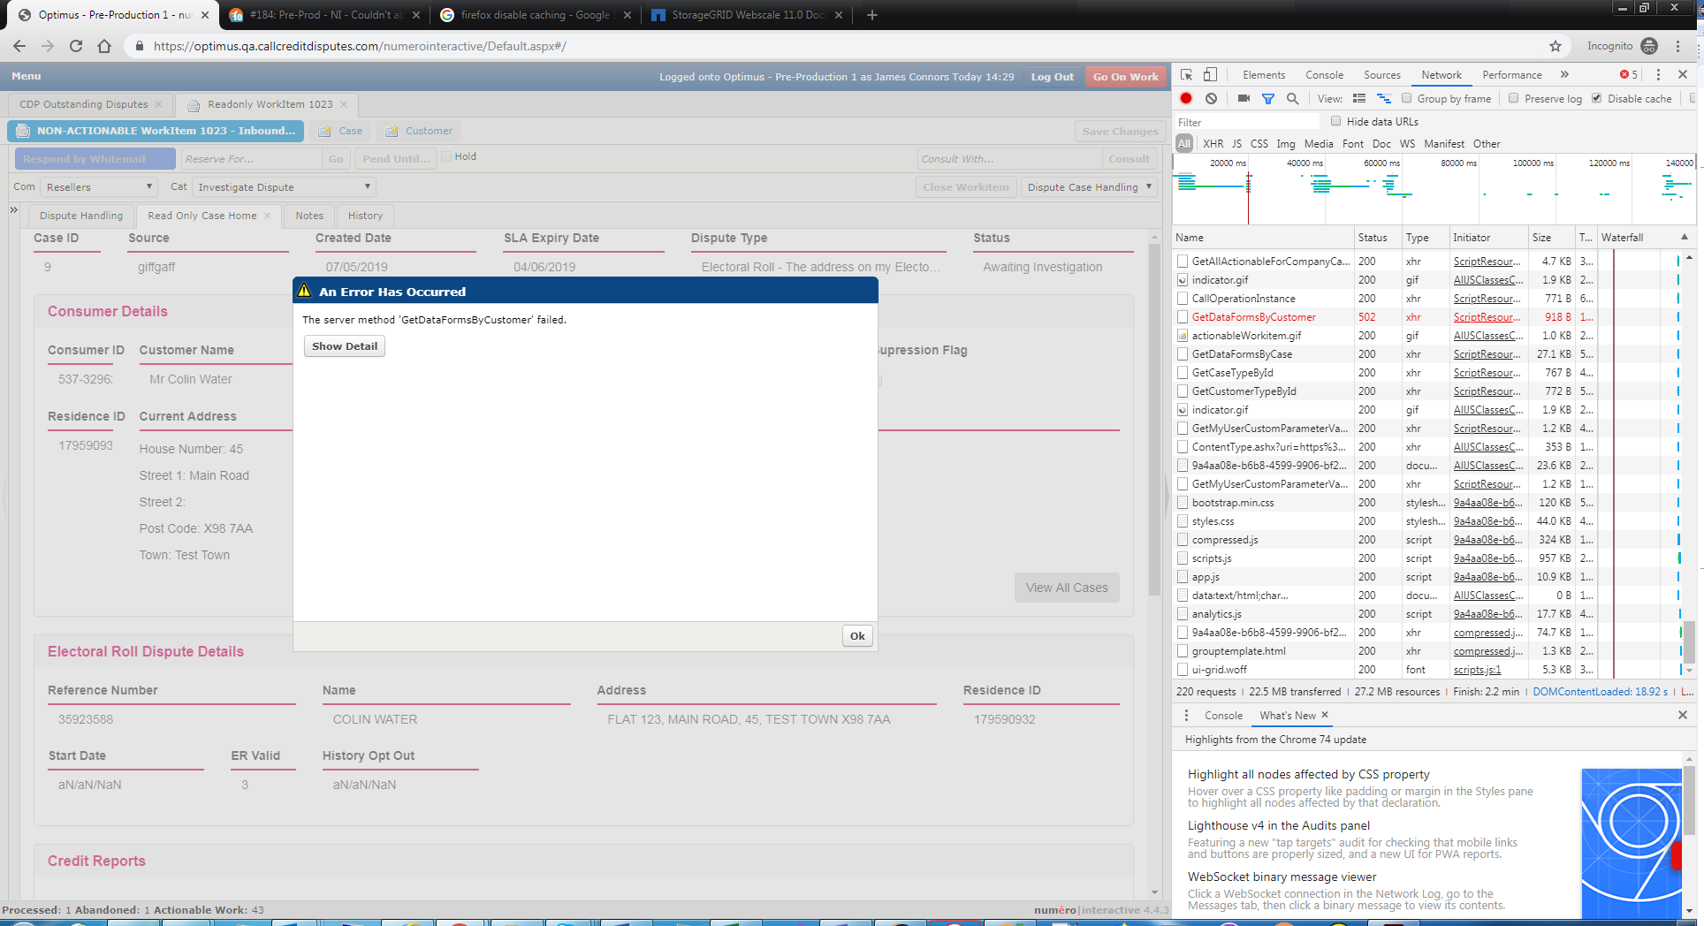

OK’d;

Closed dispute, tried a different one with no issue;

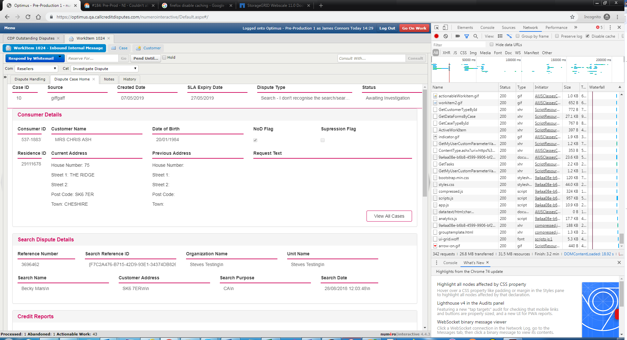

Closed and tried one that created error before;

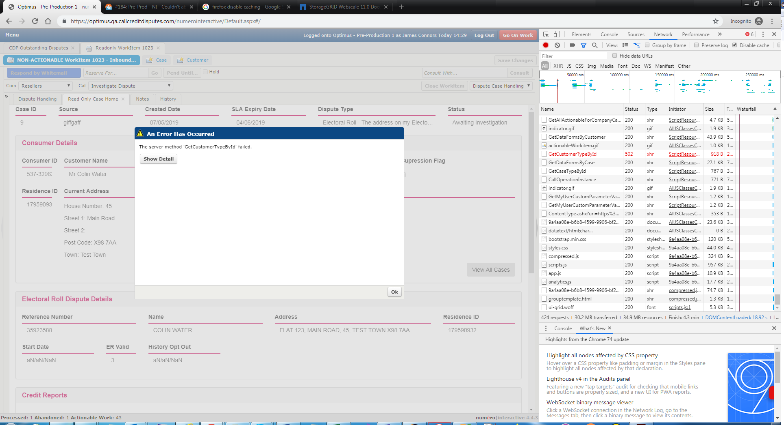

Tried different dispute without issue;

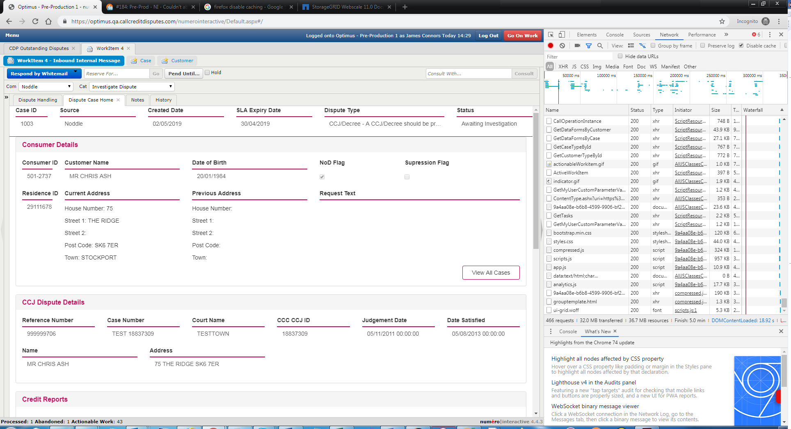

Logged out, cleared cache, closed browser, opened incognito chrome

Navigated to <https://optimus.qa.callcreditdisputes.com/numerointeractive>

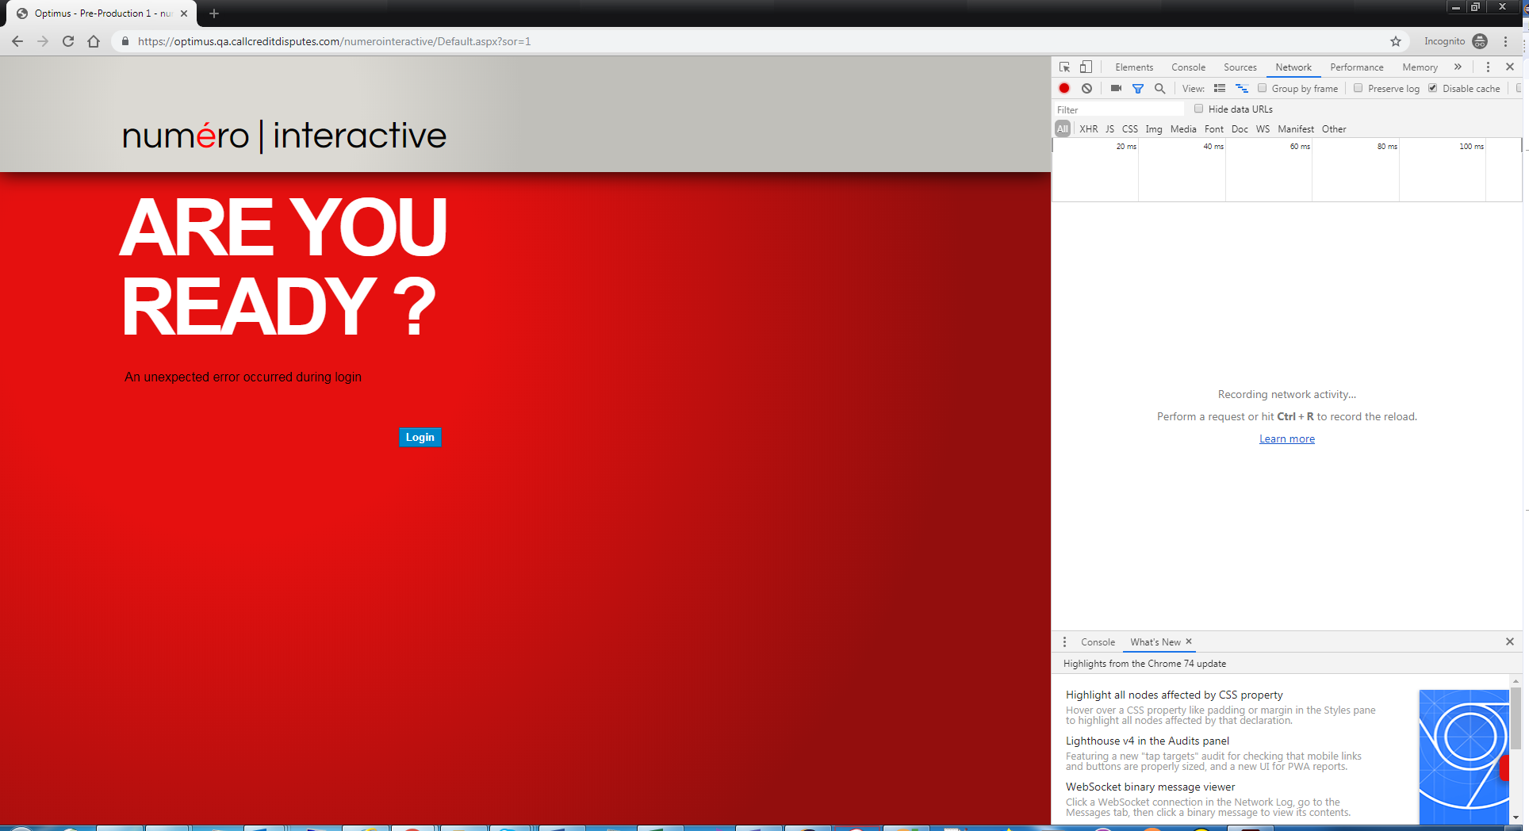

Clicked Login;

Blue bar with no menu;

